For managing this coursework, we decided as a group it would be easier to use different applications including Trello, Github, Slack and Eclipse.

# **Trello**

We used Trello to idenfity which tasks needed to be carried out and which tasks were completed. This helped us as a group breakdown the coursework to complete mini sections of it. It also helped as during this module’s coursework we had many other assignments to complete.

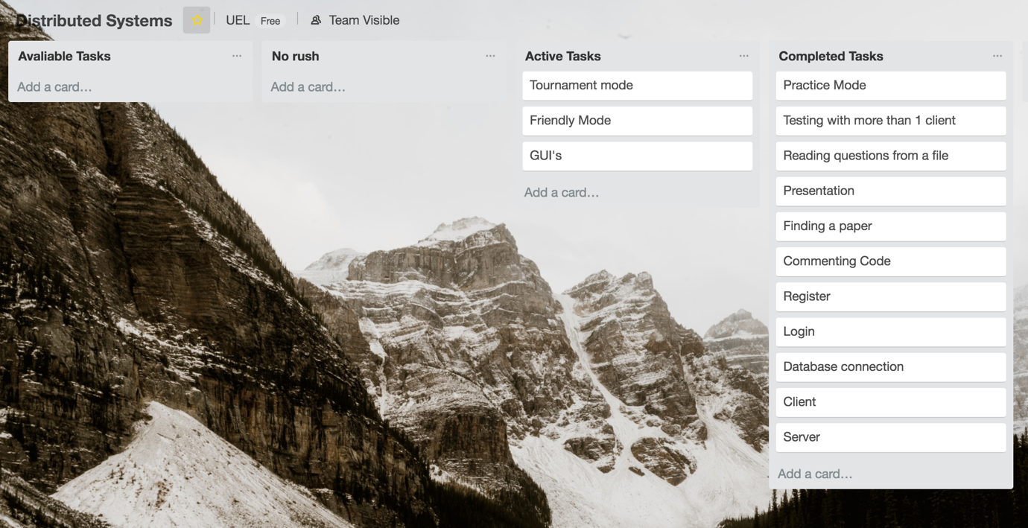

# **Github**

Github was another application we used. This application allowed us to have different versions of the code while working on it and also allowed everyone to access the files easily. Using this application was handy as sometimes when a change was made, we had to go back to our old code to identify where the mistake was coming from.

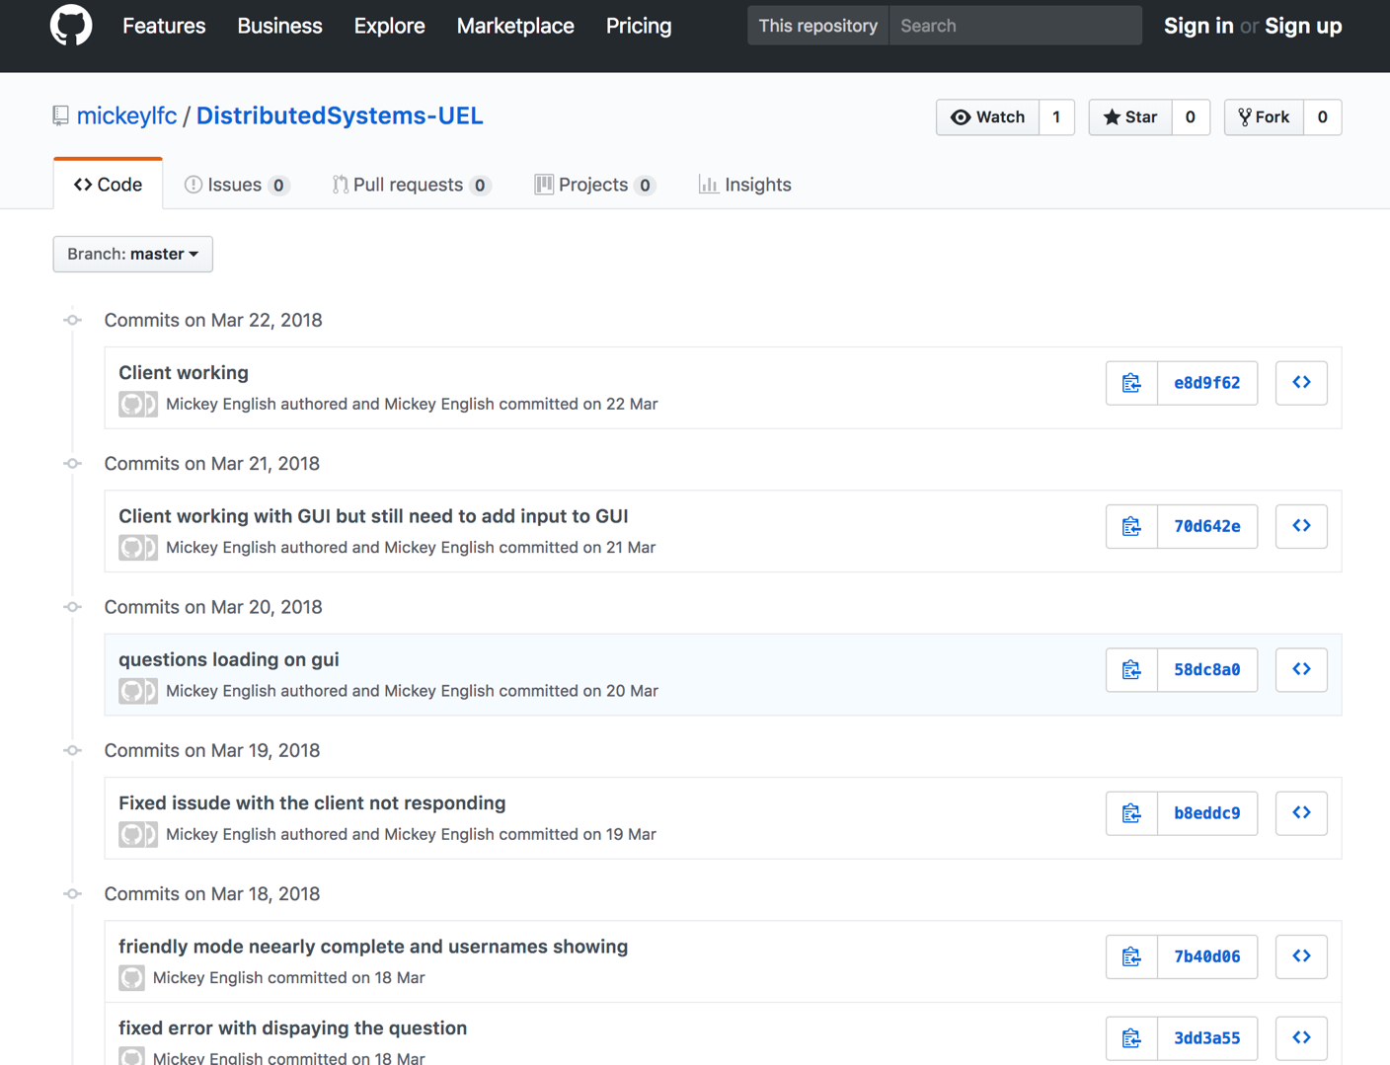

# **Slack**

Similar to Github and Trello, we used Slack to communicate with each other outside of University and share work. Slack has helped us as a group keep in touch throughout the assignment and minimised the chances of more than one group member doing the same task.

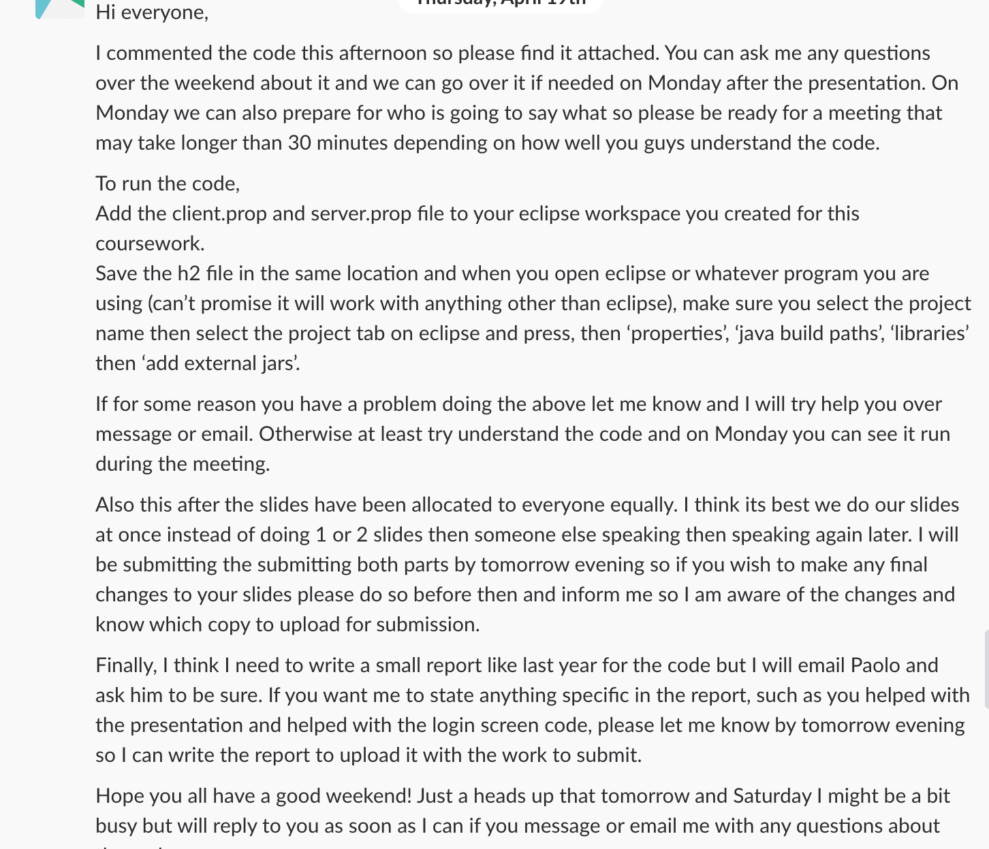

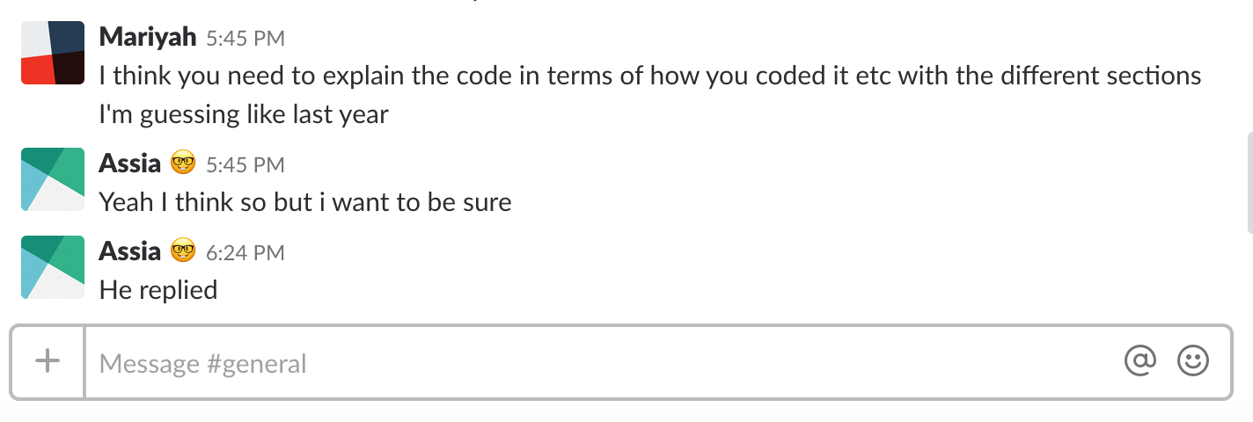

# **Eclipse**

As a group to develop the Quiz Game we used Eclipse to write Java code. We used this application as we all have experience with it from previous years and it is free to use. In addition, using the same application allowed us to easily share work and read other group members work since sometimes when using two Java development applications, the code does not respond.

